How To Export Panoramic MIDI data for Analysis in Fiji or Imaris
By: Ofra Golani, BioInformatic Unit, Biological Services Department

When working with Digital Histology data acquired using the 3D Histech Panoramic MIDI, you get huge images that can be viewed with the (free) Panoramic Viewer software. For quantitative analysis of this data people either use HistoQuant software by 3D Histech which can analyze the whole slide, or export snapshots of selected small Regions Of Interest (ROI) and use them for further analysis with other software packages like Fiji/ImageJ, Imaris or ImagePro. If you want to be unbiased it is better to use the whole tissue, however HistoQuant is quite limited in its functionality, it is also slow, limited in the size of ROI that can be actually analyzed and tends to crash or get stacked quite often.
There are other commercial software available for analyzing digital slides such as more modules from 3D Histech as well as VisiomorphDP and TissuemorphDP by Visiopharm and TissueStudio by Definiens, both of them are very expensive and not available at WIS.
However, thanks to LOCI-Bioformats you can now export Panoramic MIDI data of a whole tissue in High resolution for further analysis in software packages like Fiji (ImageJ) or Imaris, in which you can perform various quantitative image analyses. This is done by exporting the data from Panoramic Viewer to tiled tif file and reading this data using LOCI bioformats plugin in Fiji or Imaris. This document describes how to do this.
Note that the scaling in the exported files is not correct and you should set it manually as explained below.
Contents
1. Inside Panoramic Viewer 2
Export the File 2
Check for scaling of your data 3
2. In Fiji / ImageJ 5
3. In Imaris 6

Inside Panoramic Viewer

NOTE:
in order to draw an TOI in Panoramic Viewer you should copy your data from BioImg which is read-only disk to your own disk (which is writable).

Export the File
- Create a box or exact caption around your tissue. Give it a meaningful name, as it will be part of the exported file name.
- Open the Slide Export window by choosing Slide Export from the File Menu to (fig 1)

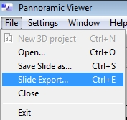
Figure 1: Slide Export menu, Panoramic Viewer
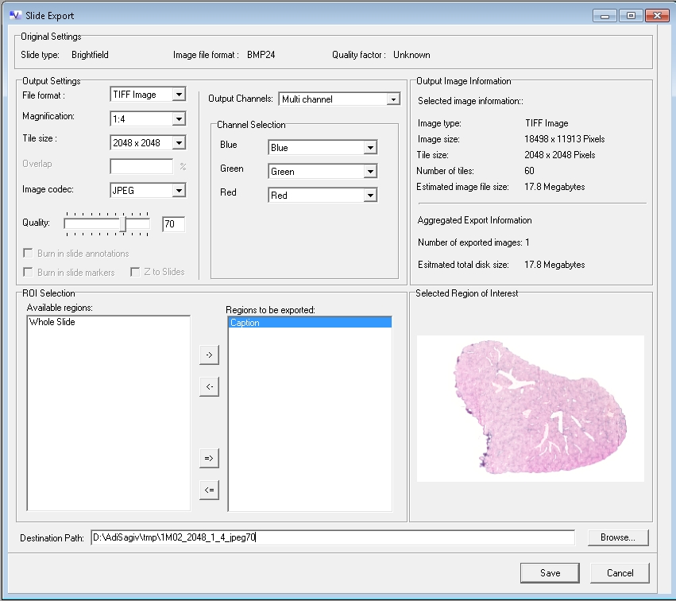
Figure 2: Slide Export Window, Panoramic Viewer

- Set File format to TIF (fig 2)
- Set Magnification to the desired value. There is a trade-off between resolution and file-size. The estimated image file size is shown on the right panel. For example 1:4 means binning of 4, later on you should verify that you have enough details in the output file.
- Select the tile size – I use 2048*2048, but it doesn’t really matter
- Select the compression: either “No compression” or “JPEG” with “Quality” no less than 70%. As for magnification there is a trade-off between resolution and file size, you should try it yourself on your data.
- Select the ROI
- Select the output destination path, the name of the ROI is appended to the name you give.
- Click the Save button

Check for scaling of your data
- Click the Information Options icon and choose Slide Information (fig 3).
- Write down the value of Micrometer / Pixel (fig 4)
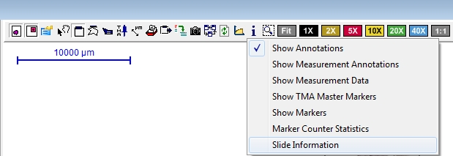
Figure 3: Slide Information Menu, Panoramic Viewer

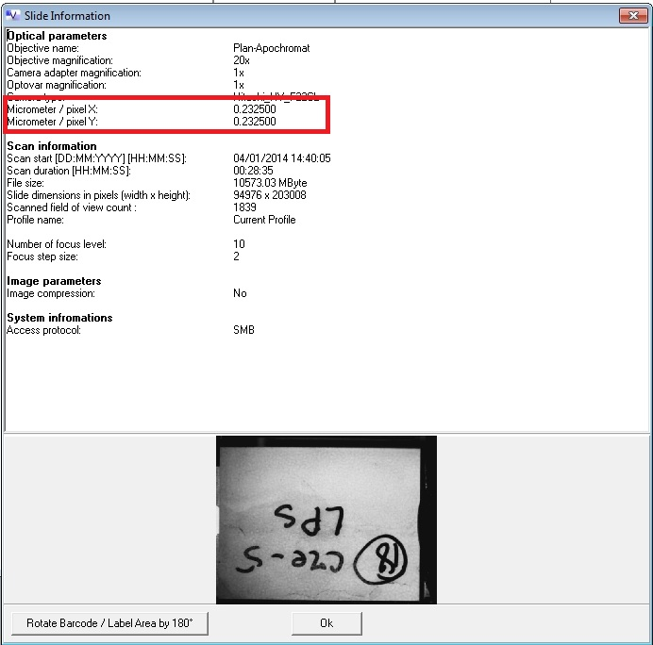
Figure 4: Slide Information Window, Panoramic Viewer

Hint: if you want to make sure you have the correct scaling, you can create measurement annotations and have them appear on top of the exported image. However once you are convinced, then for image analysis it is better to use images without overlay.
To create measurement annotation use Measurement Options ⇒ Create Distance Measurement Annotation (fig 5)
To export the measurement annotation, check the Burn in slide annotations checkbox in the slide export window.
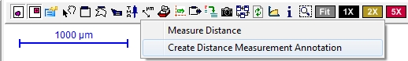
Figure 5: Create Distance Measurement Annotation, Panoramic Viewer

In Fiji / ImageJ

To open the exported files you will need the LOCI BioFormats plugin. If you don’t have it, you can download it from:
http://downloads.openmicroscopy.org/bio-formats/4.4.10/
- Choose Plugins ⇒ LOCI ⇒ Bio-Formats Importer
- A Window will pop-up (fig 6). Click the OK button
- The file will be opened as 3 channel image. To convert it to color image, use Image ⇒ Color ⇒ Stack To RGB
- To set the scale correctly you should
  - Go to Image ⇒ Properties
  - Set Pixel Width and Pixel Height to (Micrometer/Pixel) * Magnification. Make sure the unit of measurement is micron. For example suppose the Micrometer/Pixel = 0.2325, and the binning factor is 1:4 , then the pixel Width and Pixel Height values should be (0.2325*4)=0.93
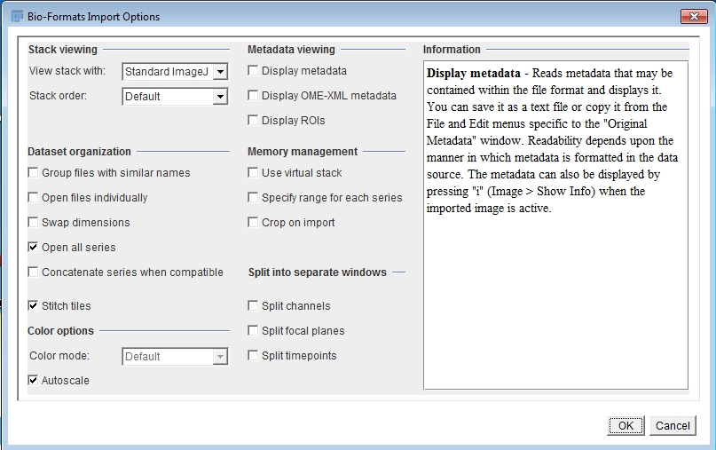
Figure 6: Bio-Formats Importer, Fiji / ImageJ
Relevant Useful Function in Imaris would be Image ⇒ Adjust ⇒ Threshold Colour / Color Threshold
See also:
- Colour Analysis Tools in ImageJ
http://www.fmhs.auckland.ac.nz/sms/biru/_docs/colour_analysis_tools_in_imagej.pdf
- Using ImageJ to Select & Measure Areas Based on Color http://www.med.upenn.edu/cellbio/documents/ImageJ_ColorSegmentpdf.pdf
- Quantifying Stained Liver Tissue:
http://rsbweb.nih.gov/ij/docs/examples/stained-sections/index.html
- Color Segmentation plugin:
http://bigwww.epfl.ch/sage/soft/colorsegmentation/

In Imaris
Imaris may be good option for analysis of fluorescent data. It does not have tools for color based quantification.
- Open the file using Fiji⇒ Plugins⇒ LOCI ⇒ Bioformats Importer (fig 7)
Note: This is implemented in Imaris using Fiji XTension, if it is not functional (grayed), you should install Fiji on your computer and set the path to Fiji using Fiji ⇒ Options (fig 8).
- Set the scaling using Edit ⇒ Image Properties. A new window will be opened. Set Voxel Size for both X and Y to (Micrometer/Pixel) * Magnification. Make sure the unit of measurement is micron. For example suppose the Micrometer/Pixel = 0.2325, and the binning factor is 1:4 , then the pixel Width and Pixel Height values should be (0.2325*4)=0.93.
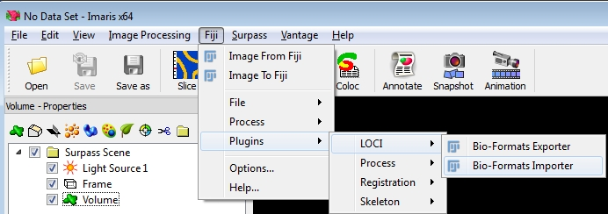
Figure 7: Bio-Formats Importer, Imaris
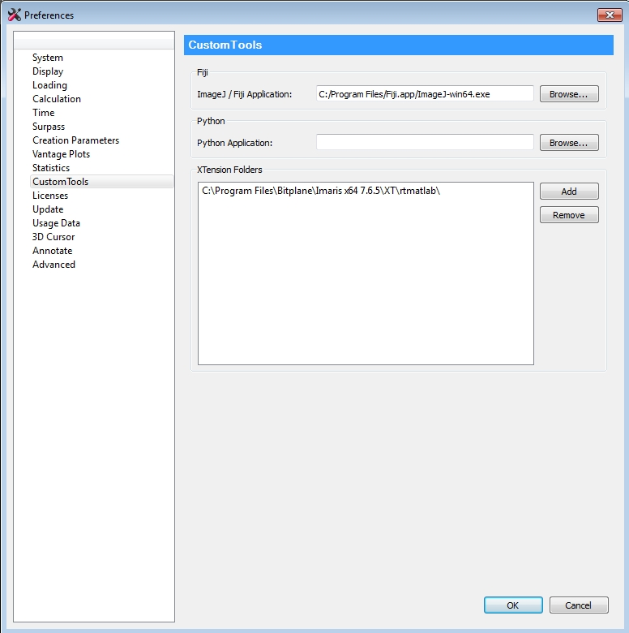
Figure 8: Fiji Options in Imaris

